Miguel Fernandez Brazon
4/19/26
Module 5.2 Programming Assignment

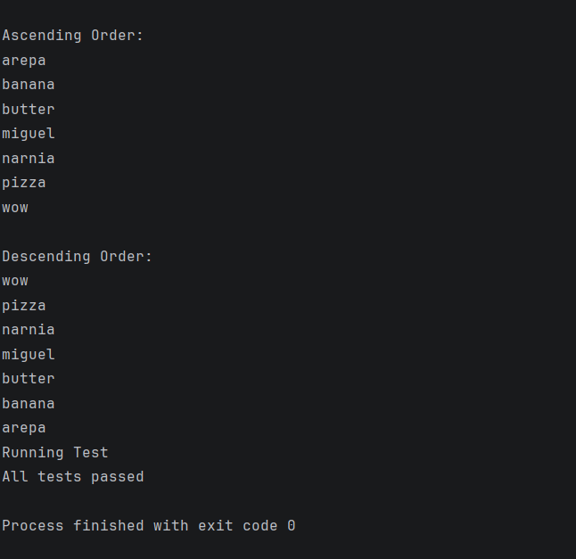

https://github.com/concord808030-tech/CSD420-308A-Advanced-Java-Programming-

